1. Covered introductions.
2. AWS Hosting - servers in the cloud that host dotNet apps, and databases.
   1. EC2 - Primary hosting server
   2. ECs - “docker”
   3. S3 - File storage
   4. RDS - Relational Database Service
3. Client does not expect “everything” to be virtualized, but some primary items.
   1. Has selected items that are likely priority for virtualization in a screenshot he has taken.
   2. Client wants a visualizer for Accutech AWS.
      1. App will visualize running services quickly and in a way that a user can quickly see all of their environments without having to have 3+ consoles open.
      2. Also needs to be able to see the connections between them.
      3. Sees it primarily as a desktop application due to average user story and duration of time for development, and required visualizations.
         1. Is open to the software being web-based.
      4. Should not be formatted for mobile setting.
4. Used EC2, Docker and RDS as examples.
   1. It is frustrating to see all the “fluff” on the standard AWS page.
   2. Both have consoles that are clunky and look very different from each other.
   3. Notably, client likes the interface quality of EC2 much more than Docker.
5. Q & A
   1. .NET Core is preferred stack. Would like this for project.
   2. Client seems keen on using SyncFusion WPF components.
      1. Likes the diagramming tool found in this suite.
      2. SyncFusion has free claimable licensure.
   3. Wants us to use Jira/Confluence/BitBucket
   4. As of now, client does not have any “hard” requirements. Simply the high-order requirement “visualize it better than it currently is in AWS console(s)”
   5. Wants the app to have a depth of 2; the service and then status/detailed information. The 2nd depth is perhaps a submenu that points to links.
   6. Client prefers Monday @5pm for meetings.
6. Closing comments
   1. Client is okay with frequent emails.
   2. Will cover further requirements later.

Design Mockup Nick H

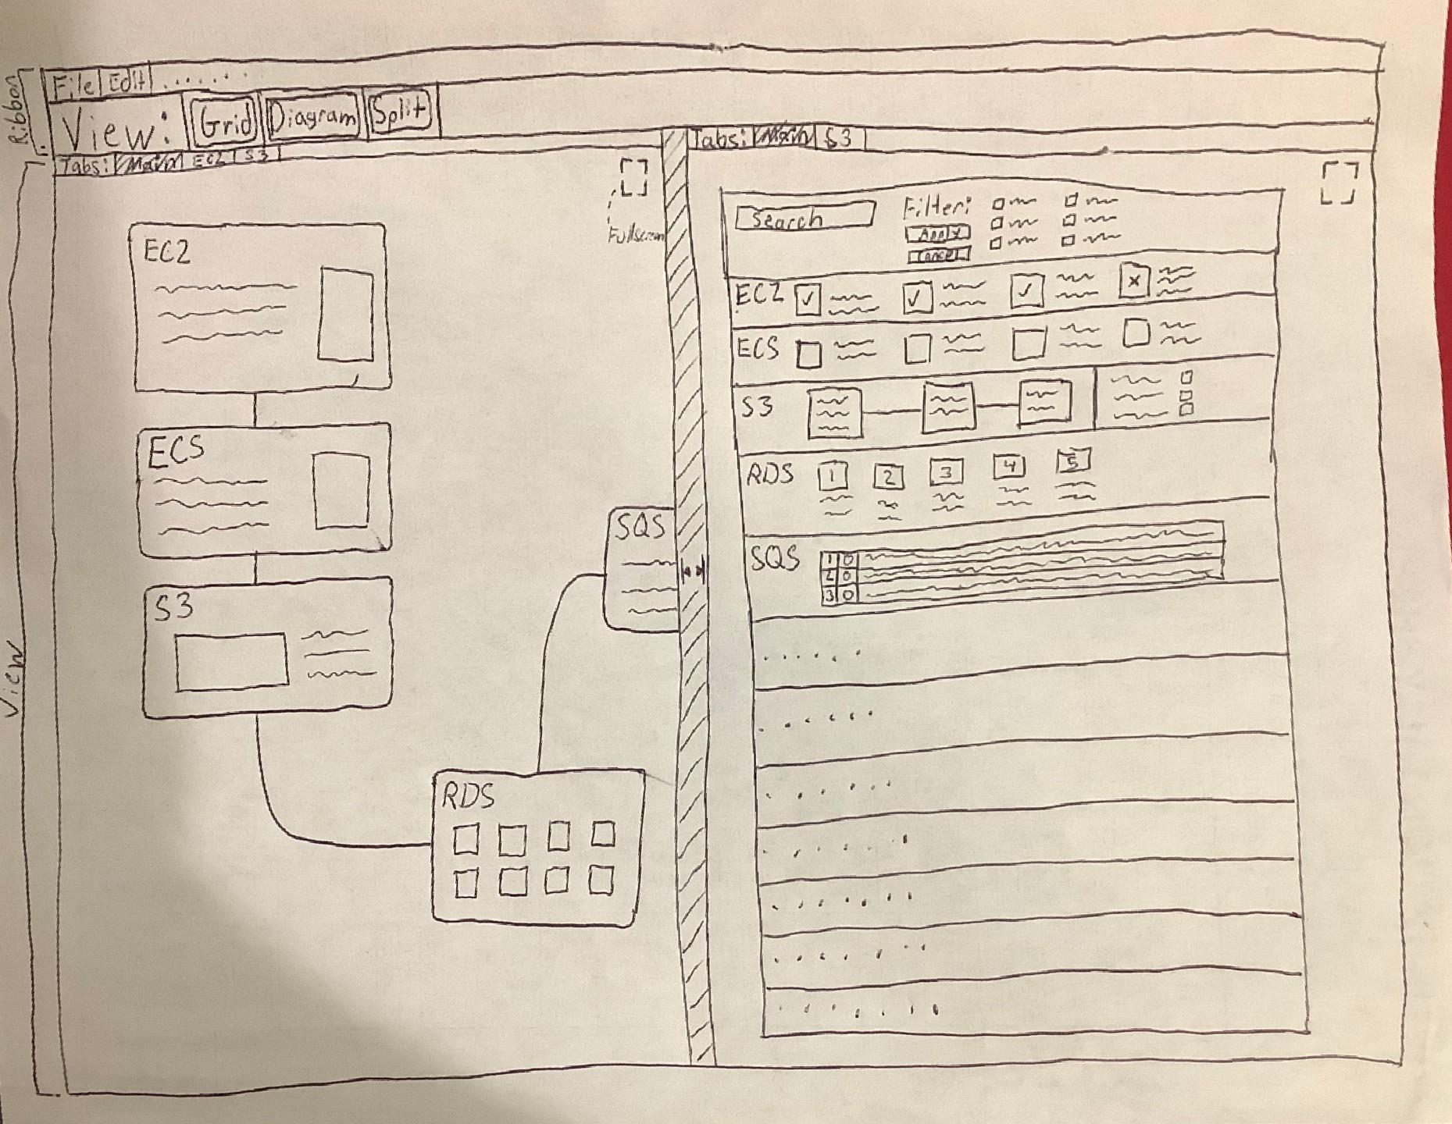

For starters, as far as the view and the depths, my idea was to select a tab for a specific aws tool such as EC2 and that would replace the corresponding view you tabbed from (if that makes sense). What you see in the photo is what each view would look like from the top depth meaning the grid and diagram views, and I tabbed them as "main" on each side. You'll also notice a slider in the middle which would dissapear if you fullscreened ethier view. I didn't put much effort or thought into the ribbon because I feel like a lot of what will be up there are basic application tools like what you would see in the microsoft word ribbon. Finally, this is the first sketch we've made so obviously I'm not married to any of this, this is just what first came to me.